**STAT 40001/ STAT 59800 Statistical Computing Fall 2020**

**Lab-9**

1. The data “vacation” provided in the link below describe a sample of 200 Chicago households regarding their vacation. The data includes the following variables

1. miles miles traveled per year

2. income annual income in $1000's

3. age average age of adult members of household

4. kids number of children in household

<http://www.principlesofeconometrics.com/poe4/poe4stata.htm>

1. Import the data in R (Note the format of the data)

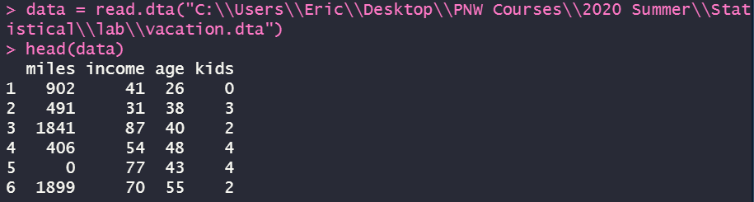

1. Display the miles distribution based on the number of kids by drawing parallel box-plot



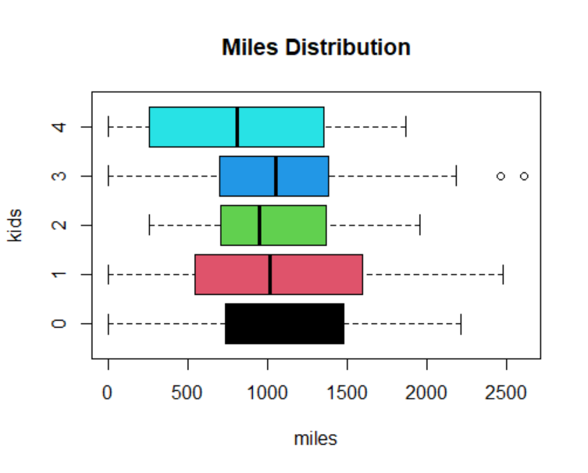

1. Draw histogram along with boxplot of the income data. (You will need to use UsingR packages and simple.hist.and.boxplot(your data)  
   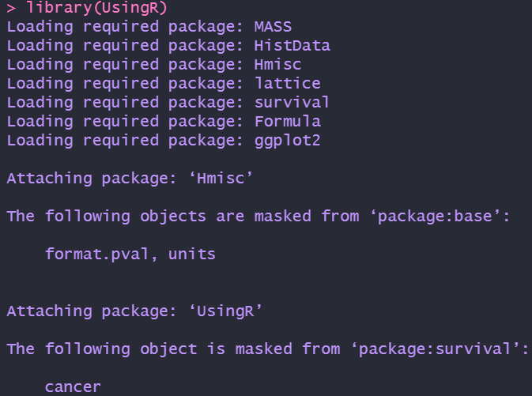  
     
   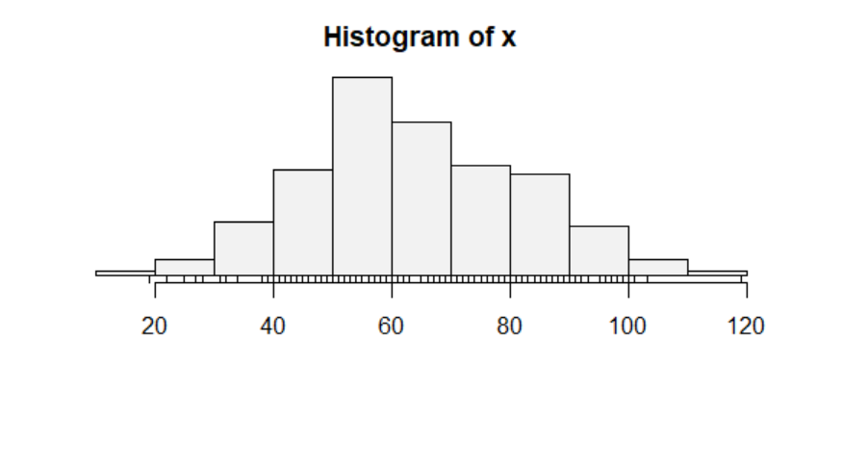
2. The following are the head circumferences (centimeters) at birth of 15 infants in a local hospital

33.38 32.15 33.99 34.10 33.97 34.34 33.95 33.85

34.23 32.73 33.46 34.13 34.45 34.19 34.05

Construct a 95% confidence interval for the head circumferences (centimeters) at birth of all infants born at the local hospital.

*The default confidence level is exactly 0.95, so we don’t need to specify it in advance*  
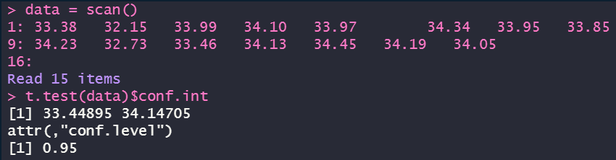

1. The National Hurricane Center (NHC) of the National Oceanic and Atmospheric Administration (NOAA) tries to predict the path each hurricane will take. But hurricanes tend to wander around aimlessly and are pushed by fronts and other weather phenomena in their area, so they are notoriously difficult to predict. Even relatively small changes in a hurricane’s track can make big differences in the damage it causes. The link below give the mean error in nautical miles of the NHC’s , 24, 48 and 72-hour predictions of Atlantic hurricanes for 1970-2017. NOAA refers to these errors as the Forecast error or the Prediction error and reports annual results.

<https://dasl.datadescription.com/datafile/tracking-hurricanes-2016/>

1. Import the data in R

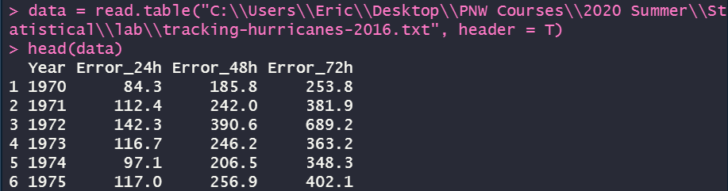

1. Display the 24-, 48- and 72-hours errors creating appropriate graph.



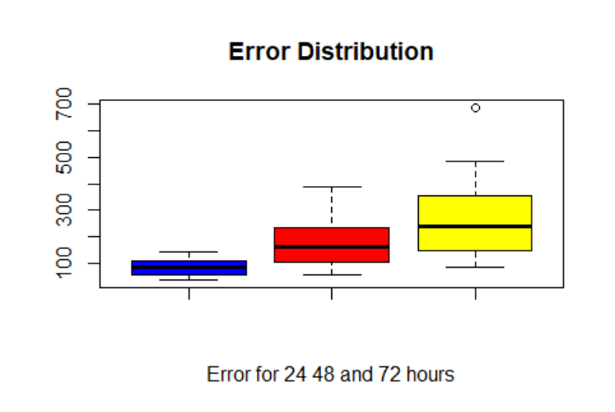

*I also made three q-q plots for each of them.*



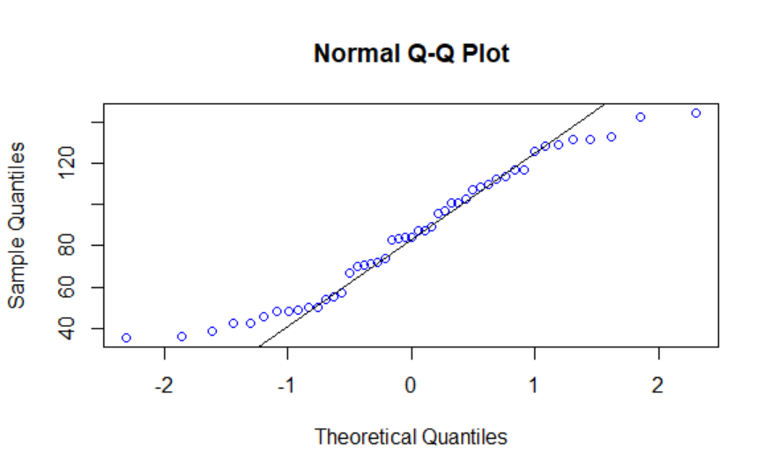



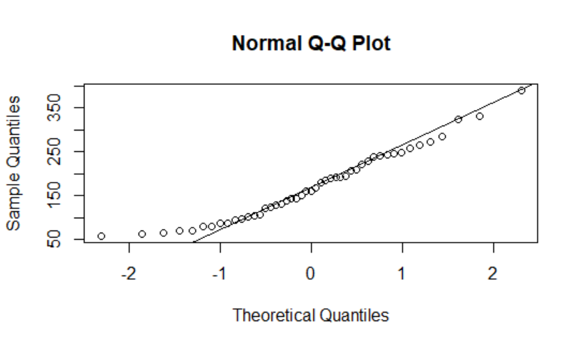



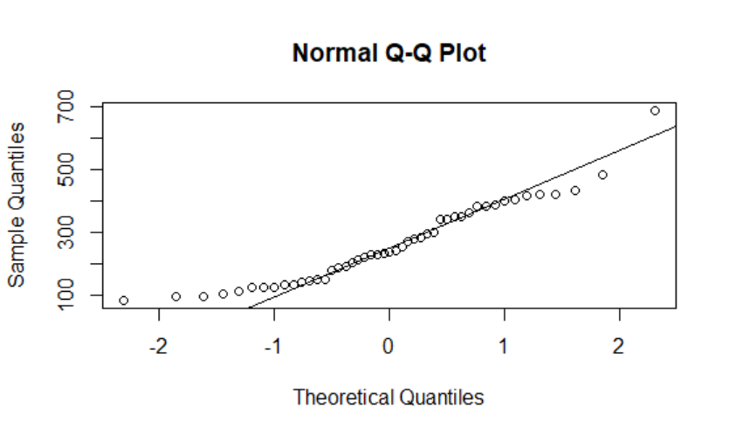

1. Construct 90% confidence interval for 72 hours prediction errors

